User Guide

jWebSocket
Stock Ticker Demo

1. Characteristics of the solution
Stock Ticker Demo is an application that shows and promotes data in real time by means of a stock ticker. Allows users to see the behavior of the quotations of the companies as well as do shopping and sales, also viewed using a graph the behavior of your deposit purchases. The benefits that offers the users are that, obtaining the data of the quotations in a more efficient way augments the trust on time of taking purchase of decisions-blows of actions diminishing the loss of add financial.
Stock Ticker Demo is a carried out application by means of the protocol of WebSocket communication, which furnish that achieves show it data of the tables in real time furnishing high levels of speed and |escalabilidad|.
jWebSocket is the frame of work in which went developed the application, showing the potentialities that this one offers to promote data of the boards of quotations in the web in real time.
The level of |escalabilidad| of the supported connections for the jWebSocket servants permits high concurrence of users. Proofs of stress carried out to a jWebSocket servant throws in consequence 10 000 connect persons in attendance without affecting the time of answer of the application. This become muddled guarantees not single carry out processes in real time but can guarantee a high number of users using a same service in the same instant of time, which it means that 10 000 appear in person in the whole world it is able to accede to the Ticker Demo stock application.
2. Main functionalities
Functionalities of Stock Ticker Demo:
1. Show stock ticker.
2. Show historial.
3. Buying instruments.
4. Selling instruments.
5. Chart deposits.
6. Show deposits.
7. Registering user.
8. Authenticating user.

Stock Ticker Demo is used principally in the financial sector. It is a fundamental element for takes it of agile and efficient decisions, represented great advantage in the worldwide market, since permits know the financial state of the undertakings in the bag of values, moreover take important decisions of purchase and sale of actions of the same thing. It is of great help to investors and businessmen facilitating take them the control of his inversions and financial states in real time.
3. Problems to be solved
Problem | Contributions of the solution
Traffic of information or bandwidth in the process of step of data by means of a board of quotations in the web. | Stock Ticker Demo is an application of management of data by means of a board of quotations, the who by means of the WebSocket protocol reduces enormously the traffic of information of the application.
Latency in the process of step of data by means of a board of quotations in the web. | Stock Ticker Demo is a web application that offers the possibility of carrying out the process of step of data in a board of quotations in real time through the WebSocket protocol.
4. Glossary of Terms
Stock Ticker: It permits that the undertakings reflect his finance, they introduce orders and carry out negotiations of purchase and blows of values by means of an application where the information of the tables it varied in a dynamic way in the time.
Real Time on the Web: It is possible when the client receives messages from the server without prior request and end users receive updates simultaneously.
WebSocket: It is a technology that provides a bidirectional communication channel and full-duplex over a single TCP socket. This protocol solves the limitations of HTTP, by establishing a full-duplex communication (TCP) between the client and server, replacing the half-duplex communication (HTTP). Is reduced, in large proportions, the network traffic given that to the establish WebSocket communication between the client and the server, there is only sending 2 bits, eliminating the HTTP headers.
jWebSocket framework: Is a new technology aimed at developing WebSockets based applications that provide high levels of speed, scalability, security and the real-time work, a key element for online collaboration today.
Full-Duplex: Condition of the elements that allow the entry and exit of data simultaneously.
Socket: Method for the communication between a client program and a server program on a network.
Half-Duplex: Means that the method or protocol for sending information is bidirectional but not simultaneous.
5. Model of the solution
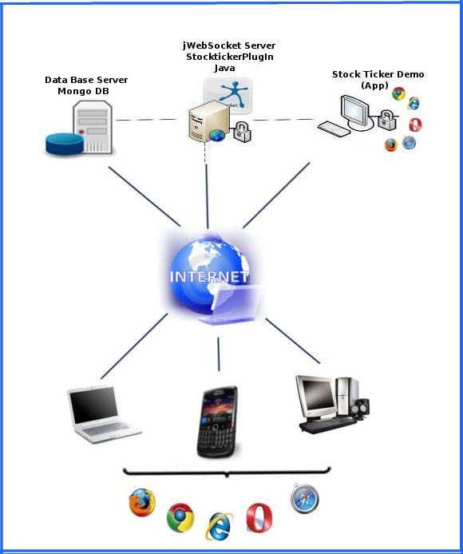
To accede to Ticker Demo stock the client must use a navigator that supports the WebSocket protocol. As soon as it connects to him to the application the user must be registered in the application and afterwards authenticate . One time in the application showed the state of the quotations of the undertakings, then is able to make his buy visualizing the in the table of deposits moreover it is able to see the state of this deposit by means of a graph y sell the reflex actions in the deposits. Each action that carries out the user will be sent to the jWebSocket servant, that it is the representative of keep him/her/it in the servant of base of data.
7. Requirements for the use
To give am accustomed you to the Ticker Demo stock application it must have connection to Internet and use whoever of the navigators that support the protocol of WebSocket communication. Someone of them it is Google Chrome 4, Safari 5, Mozilla Firefox 8, operates 11 and Internet Explorer 10.
8. Roles of the solution
System User: it has access to all the functionalities that offers the system and it is in interaction with the same thing.
9. System Operation
Initial view: to the accedes to the application the user must be registered in the application and afterwards authenticate.
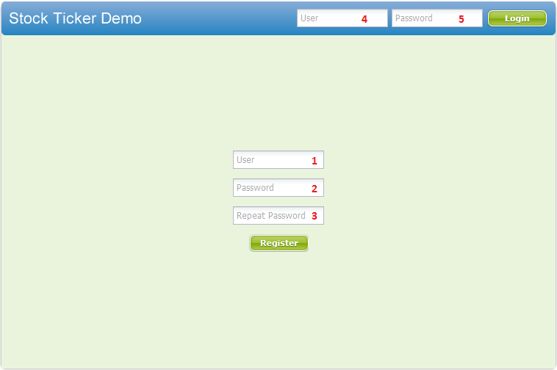
1 -------- Field where the inserted user the ID that will have in the application.
2 -------- Field where the inserted user your password.
3 -------- Field where the user repeats the password to verify that is correct.
-------- Save user information.

4 -------- Field where the user introduces your ID to accede to the application.

5 -------- Field where the user introduces your password to accede to the application.

-------- Access the application.

Main view: When authenticating is shown the state of the quotations of the undertakings and the deposits of the authenticated user.
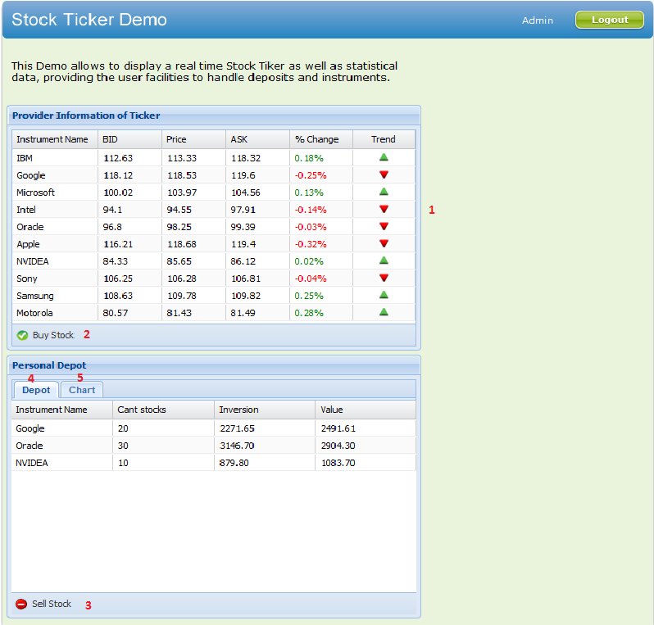

-------- Exits the application.

1 -------- Sample the window that permits to the user see the state of the price of the die instrument a dobleclick in the same thing.

2 -------- Sample the window that permits to the user makes his buy.

3 -------- Sample the window that permits to the user makes his sell.

4 -------- Sample a board in which will see to him reflected the deposit of the purchases of the user.

5 -------- Sample the area where will be reflected the graphics of the deposits of the user.
Show historial of the price of the actions: when giving dobleclick in the row of the undertaking that you want to obtain the history of the price of his actions.
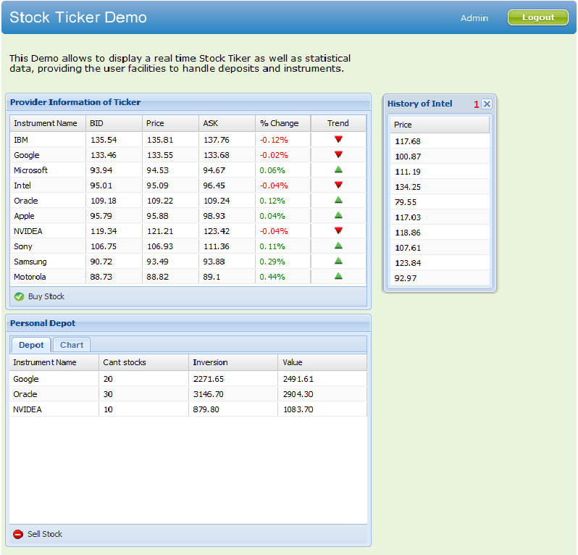
1 -------- Close the view.

To show view of the formulary to go shopping: when giving click in the Buy Stock button
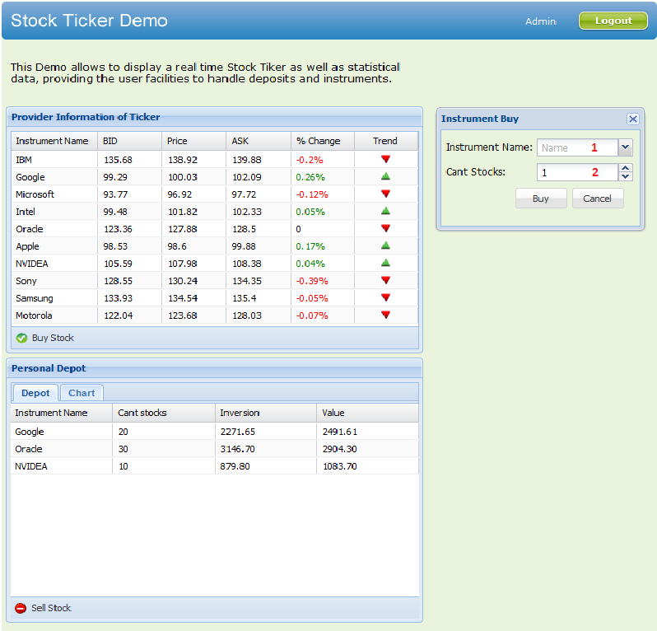

1 -------- Field where the user inserted the name of the instrument that wants buy.

2 -------- Field where the user inserted the quantity of actions that wants buy.

-------- Buy the instrument.
-------- Canceling the purchase and closes the window.
To show view of the formulary to do blows: when giving click in the Sell Stock button.

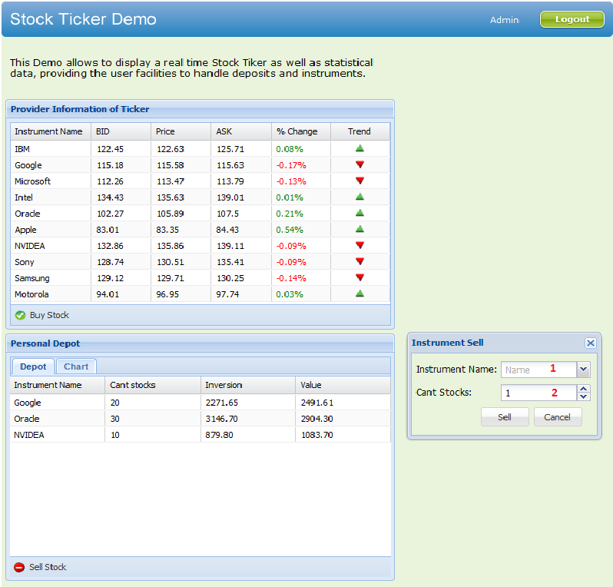
1 -------- Field where the user inserted the name of the instrument that wants sell.

2 -------- Field where the user inserted the quantity of actions that wants sell.

-------- Sell the instrument.
-------- Canceling the sell and closes the window.

Showing graphics deposits of deposits: when giving click in the Chart eyelash
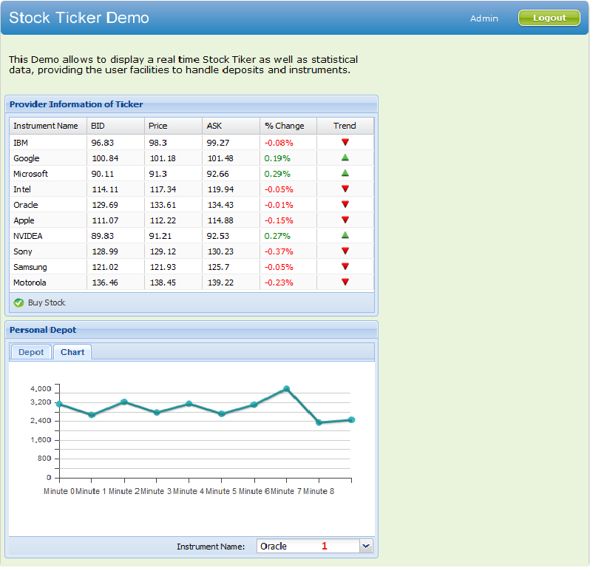
1 -------- Combobox to select the instrument that wants chart.

10. Rules of the solution
R1: If the user mistaken when repeating the password, during the process of register of user, the system broadcasts a message of error and continue with the normal flux. Solution: The user must return to register securing that coincide the passwords.
R2: register of user, the system broadcasts a message of error and continue with the normal flux. Solution: The user must return to register inserting other user name.
R3: If the user it is mistaken when writing your user or password, during the process of access to the application, the system broadcasts a message of error and continues with the normal flux. Solution: The user must again repeat your user and password.
R4: If the user introduces an user that doesn't exist, during the process of access to the application, the system broadcasts a message of error and continue with the normal flux. Solution: The user must be registered in the system.
R5: If the user doesn't select the instrument that wants buy, during the process of purchase of instruments, the system broadcasts a message of error and continues with the normal flux. Solution: Selecting the instrument that wants buy.
R6: If the user during the process of purchase of instruments, wants buy an instrument that is not in your deposit of purchases, the quantity cannot surpass of 100 or if the user buys an instrument that already exists in your deposit of purchases, the existent quantity more that wants buy cannot surpass of 100, otherwise the system broadcasts a message of error and continue with the normal flux. Solution: Selecting an agreed quantity to which wants buy.
R7: If the user doesn't select the instrument that wants sell, during the process of sale of instruments, the system broadcasts a message of error and continues with the normal flux. Solution: Selecting the instrument that wants sell.
R8: If the user during the process of sale of instruments, wants sell an instrument, the quantity cannot surpass to the existent quantity, otherwise the system broadcasts a message of error and continue with the normal flux. Solution: Selecting an agreed quantity to the values of your deposit .

